Tax Abatement Agreement

between

Foard County, Texas and

Pease River Solar LLC

State of Texas

County of Foard

This Tax Abatement Agreement (this “Agreement”) is made and entered into by and between Foard County, Texas (the “County”), acting through its duly elected officers, and Pease River Solar LLC, a Delaware limited liability company, to be located on a portion of the tract of land within the Pease River Solar Reinvestment Zone, more specifically described in Exhibit A to this Agreement. This Agreement becomes effective upon final signature by both parties (the “Effective Date”) and remains in effect until fulfillment of the obligations described in Section IV herein (the “Term”), unless terminated earlier as provided herein.

Recitals

WHEREAS, the County indicated its election to be eligible to participate in tax abatements and established the Foard County Tax Abatement Guidelines and Criteria (the “Guidelines”) by resolution most recently dated on or about April 13, 2026;

WHEREAS, the Commissioners Court of Foard County, Texas (the “County Commissioners Court”) desires to promote economic development within its jurisdiction as authorized by the Property Redevelopment and Tax Abatement Act, as amended (Texas Tax Code § 312.001, et seq.), and the Guidelines;

WHEREAS, on August 24, 2026, a hearing before the County Commissioners Court was held, such date being at least seven (7) days after the date of publication of the notice of such public hearing in the local newspaper of general circulation in the County and the delivery of written notice to the respective presiding officers of each taxing entity that includes within its boundaries real property that is to be included in the Reinvestment Zone (as defined below);

WHEREAS, the County Commissioners Court, after conducting a hearing, having heard evidence and testimony, and prior to considering this Agreement, found, based on the evidence and testimony presented to it, the Reinvestment Zone met the criteria set forth in Chapter 312 of the Texas Tax Code for the creation of a reinvestment zone as set forth in the Property Redevelopment and Tax Abatement Act, as amended, and the Guidelines, in that it was reasonably likely as a result of the designation to contribute to the retention or expansion of primary employment or to attract investment in the zone that would be a benefit to the property and contribute to the economic development of the County, and that the entire tract of land was located entirely within an unincorporated area of the County;

WHEREAS, entering into this Agreement will serve the best interests of the County and its citizens and comply with the Guidelines by:

- enhancing and diversifying the economic and industrial bases of the County;

- contributing to the retention and expansion of primary employment; and

- attracting major investment that will be of benefit to and contribute to the economic development of the County;

WHEREAS, the contemplated use of the Site (as defined below) and the contemplated Improvements (as defined below) as set forth in this Agreement, and the other terms of this Agreement will encourage development of the Reinvestment Zone, are in accordance with the purposes for its creation, and are in compliance with the Guidelines and all applicable laws;
WHEREAS, Owner’s (as defined below) use of the Site is expected to favorably influence the economic and employment base of the County;
WHEREAS, the County finds that the Improvements sought are feasible and practical and will be of benefit to the real property located in the Reinvestment Zone, to the Site, and to the County after expiration of this Agreement;
WHEREAS, the County finds that the terms of this Agreement and the proposed Improvements and Eligible Property subject to this Agreement meet the Guidelines;
WHEREAS, a copy of this Agreement has been furnished, in the manner prescribed by law, to the presiding officers of the governing bodies of each of the taxing units in which the property subject to this Agreement is located;
WHEREAS, this Agreement was approved at a regularly scheduled meeting of the ‎County Commissioners Court in accordance with the Open Meetings Act, as amended, preceded by at least thirty (30) days by notice of such public meeting in compliance with Section 312.207 of the Texas Tax Code; ‎and
NOW, THEREFORE, in consideration of these Recitals, premises, the promises, mutual covenants, and agreements contained in this Agreement, and for other good and valuable consideration, the receipt and adequacy of which are hereby acknowledged, the County and Owner agree as follows:
I. Authorization

This Agreement is authorized and governed by Chapter 312 of the Texas Tax Code, as amended, and by the Guidelines.

II. Definitions

As used in this Agreement, the following terms shall have the meaning set forth below:

- “Abatement” means the full or partial exemption from ad valorem taxes on property in a Reinvestment Zone as provided herein and in no event can the duration of the Abatement period exceed ten (10) years.

- “Base Year” means the Calendar Year in which the Effective Date occurs.

- “Calendar Year” means each year beginning on January 1 and ending on December 31.

- “Certificate” means a letter, provided by Owner to the County, certifying that the Project has achieved Commercial Operations, outlining the Improvements and stipulating the overall Nameplate Capacity of the Project. Upon receipt of the Certificate, the County may inspect the property in accordance with this Agreement to determine that the Improvements are in place as certified. If the Certificate indicates that certain ancillary facilities not required for Commercial Operations are still under construction on the date that the Certificate is delivered, Owner will deliver an amended Certificate to the County within thirty (30) days after all Project construction is complete.

- “Certified Appraised Value” means the appraised value, for property tax purposes, of the property within the Reinvestment Zone as certified by the Foard County Appraisal District (the “Appraisal District”) for each taxable year.

- “COD” means the date that the Project commences Commercial Operations.

- “Commercial Operations” means that the Project has become commercially operational and placed into service for the purpose of generating electricity for sale in one or more commercial markets.

- “County Property Taxes” means all categories of ad valorem taxes, whether classified as M&O, I&S, or road taxes, imposed on the Improvements by or for the benefit of the County at all rates in effect throughout the Abatement period.

- “Eligible Property” means property eligible for Abatement under the Guidelines, including: new, expanded or modernized buildings and structures; fixed machinery and equipment; Site improvements; related fixed improvements; other tangible items necessary to the operation and administration of the Project or facility; and all other real and tangible personal property permitted by Chapter 312 of the Texas Tax Code and the Guidelines. Taxes on Real Property may be abated only to the extent the property’s value for a given year exceeds its value for the year in which this Agreement is executed. Tangible personal property located on the Real Property at any time before the period covered by this Agreement is not eligible for Abatement. Tangible personal property eligible for Abatement shall not include inventory or supplies.

- “Force Majeure” includes events not reasonably within the control of the party whose performance is sought to be excused thereby, including the following causes and events (to the extent such causes and events are not reasonably within the control of the party claiming suspension): acts of God and the public enemy; strikes; lockouts or other industrial disturbances; inability to obtain material or equipment or labor due to an event that meets the definition of Force Majeure; wars; blockades; insurrections; riots; epidemics, pandemics, and outbreaks of disease; landslides; lightning; earthquakes; fires; storms; floods; high water washouts; inclement weather; arrests and restraint of rulers and people; interruptions by government or court orders; present or future orders of any regulatory body; civil disturbances; explosions; or any other event that is beyond the reasonable control of the party claiming Force Majeure.

- “Improvements” mean Eligible Property meeting the definition for “improvements” or “tangible personal property” provided by Chapter 1 of the Texas Tax Code and includes, without limitation, any building, structure, or fixture erected on or affixed to the land. Improvements specifically include the Owner’s fixed machinery, equipment and process units that may consist of solar panels (including piles, racking, and trackers), substations and switching stations, underground and overhead electrical distribution and transmission facilities, transformers, appurtenant electric equipment, communication cable, and data collection facilities to be installed, added, upgraded, or used on the Property by or for Owner and located in the County, irrespective of whether such assets are improvements or tangible personal property as defined by Chapter 1 of the Texas Tax Code.

- “Owner” means Pease River Solar LLC, the entity that owns or leases the Real Property for which Abatement is being granted, and any permitted assignee or successor in interest of Pease River Solar LLC. The term “Pease River Solar LLC” means and includes Owner. An “Affiliate” of an Owner means any entity that directly or indirectly through one or more intermediaries, controls or is controlled by or is under common control with such Owner. For purposes of this definition, “control” of an entity means (i) the ownership, directly or indirectly, of fifty percent (50%) or more of the voting rights in a company or other legal entity or (ii) the right to direct the management or operation of such entity whether by ownership (directly or indirectly) of securities, by contract or otherwise.

- “Payments in Lieu of Taxes” or “PILOTs” means the payments to be made by Owner to the County described in Section IV(D) of this Agreement.

- “Project” means the construction and operation of the Improvements on the Site as set forth in this Agreement.

- “Prime Rate” means interest at the rate periodically announced by the Wall Street ‎Journal as the ‎prime or base ‎commercial lending rate, or if the Wall Street Journal shall ever cease ‎to exist or ‎cease to ‎announce a prime or base lending rate, then at the annual rate of interest periodically ‎announced by Citibank, N.A. (or by any other New York money center bank ‎selected by the ‎‎County) as its prime or base commercial lending rate.‎

- “Real Property” means Eligible Property meeting the description for real property provided by Chapter 1 of the Texas Tax Code.

- “Reinvestment Zone” means the reinvestment zone, as that term is defined in Chapter 312 of the Texas Tax Code, created by the County by the resolution described in the Recitals, which was duly passed by the County Commissioners Court, and referred to as the Pease River Solar Reinvestment Zone, more specifically described in Attachment A to this Agreement. The fact that the designation of the Reinvestment Zone may expire before this Agreement shall not affect the terms and condition of this Agreement.

- “Site” means the portion of the Reinvestment Zone on which Owner makes the Improvements for which the Abatement is granted hereunder and which is shown on Attachment A-1. Upon completion of construction of the Improvements, the parties agree to amend Attachment A-1 to include the as-built Improvements within the Site to the extent such Improvements are not included therein.

- “Lender” means any entity or person providing, directly or indirectly, including an assignee of an initial Lender, with respect to the Improvements or Project of any (a) senior or subordinated construction, interim or long-term debt financing or refinancing, whether that financing or refinancing takes the form of private debt, public debt, or any other form of debt (including debt financing or refinancing), (b) leasing transaction, including a sale leaseback, inverted lease, or leveraged leasing structure, (c) tax equity financing, (d) interest rate protection agreements to hedge any of the foregoing obligations, and/or (e) energy hedge provider. There may be more than one Lender. Owner, at its election, may send written notice to the County with the name and notice information for any Lender.

III. Improvements in Reinvestment Zone

Owner agrees to make the following Improvements in consideration for the Abatement set forth in Section IV of this Agreement:

- Owner is proposing to construct Improvements on the Site consisting of a solar power electric generation facility with a Nameplate Capacity of approximately two hundred and seventy-five (275) megawatts (AC) located in the Reinvestment Zone. Owner agrees that its solar power electric generation facility on the Site in the Reinvestment Zone will have a minimum Nameplate Capacity of no less than two hundred and seventy-five (275) megawatts (AC) (the “Minimum Guaranteed Capacity”). If the Nameplate Capacity of Owner’s solar power electric generation facility on the Site in the Reinvestment Zone‎ is ‎less than the Minimum Guaranteed Capacity, such circumstance shall not be a default under this ‎Agreement so long as Owner pays the Annual PILOT Floor Amount specified in Section IV(D) ‎of this Agreement. It is anticipated that, if built to its minimum capacity, the solar power electric generation facility will require a capital investment of at least approximately two hundred and forty-seven million five hundred dollars ($247,500.000). The Certified Appraised Value will depend upon annual appraisals by the Appraisal District and may be more or less than the amount stated herein.

- Improvements also shall include any other property on the Site meeting the definition of “Eligible Property” that is used to produce solar electrical power and perform other functions related to the production, distribution and transmission of electric power. The County agrees, without limitation, that the solar panels, transmission lines, substations, and other related materials and equipment affixed to the land will constitute Improvements under this Agreement.

- Owner agrees that the Project shall achieve Commercial Operations on or before December 31, 2029; provided, Owner shall have the unilateral right to elect up to two one-year extensions of the required date to achieve Commercial Operations. On Owner’s written request delivered to the County before or during Calendar Year 2029, the required date to achieve Commercial Operations shall be extended to December 31, 2030. If Owner requests a second one-year extension, then on Owner’s written request delivered to the County during Calendar Year 2030 accompanied by the payment of a one-time fee of seventy-five thousand dollars ($75,000.00) to the County, which fee shall be used to offset costs incurred by the County and shall not be considered a payment in lieu of taxation, the required date to achieve Commercial Operations shall be further extended to December 31, 2031.

- Owner may terminate this Agreement at any time prior to COD by written notice to the County for any reason, including Owner’s decision to not construct the Project. Termination shall be effective on the date of the notice to the County, and Owner shall have no further obligations under this Agreement after such date.

IV. Term and Portion of Tax Abatement; Taxability of Property

- The County and Owner specifically agree and acknowledge that the property on the Site within the Reinvestment Zone shall be taxable in the following ways before and during the Term of this Agreement:

- Property not eligible for Abatement, if any, shall be fully taxable at all times;

- The Certified Appraised Value of property existing on the Site prior to execution of this Agreement shall not be subject to this Agreement and shall be fully taxable at all times;

- Prior to commencement of the Abatement period designated in Section IV(B), 100% of County Property Taxes levied on the Certified Appraised Value of real and personal property of Owner located on the Site will be owed and payable by Owner;

- All County Property Taxes on the Certified Appraised Value of Eligible Property shall be abated for the periods and in the amounts as provided for by Section IV(B) below; and

- 100% of the Certified Appraised Value of Eligible Property existing on the Site shall be fully taxable after expiration of the Abatement period designated in Section IV(B), including the remainder of the Term.

- The County and Owner specifically agree and acknowledge that this Agreement shall provide for tax Abatement, under the conditions set forth herein, of all County Property Taxes as follows:

- Beginning with the Calendar Year after the Calendar Year in which the COD occurs or the Calendar Year specified in a Notice of Abatement Commencement (as defined below) and ending upon the conclusion of ten (10) full Calendar Years thereafter, the Abatement percentage of value of Eligible Property to be abated each year is 100% for all County Property Taxes.

- As of January 1 of the Base Year, the value for the proposed Eligible Property is zero.

- The Abatement granted under this Agreement shall commence upon January 1 of the Calendar Year after the Calendar Year in which the COD occurs and shall expire at the end of the tenth (10th) Calendar Year thereafter. Owner shall provide the Certificate in writing both to the County and to the Appraisal District within sixty (60) days of the COD. The Certificate shall describe any ancillary facilities not required for Commercial Operations that are still under construction on the date that the Certificate is delivered, and if the Certificate indicates any such facilities exist, Owner will deliver an amended Certificate to the County and to the Appraisal District within thirty (30) days after the construction of all Improvements is complete. Such ancillary facilities, once completed and if eligible, shall become part of the Eligible Property eligible for the Abatement under this Agreement.

- If Owner, at its sole election, desires that the ten-year Abatement period commence prior to January 1 of the of the Calendar Year after the Calendar Year in which the COD occurs, then Owner may deliver a notice to the County and County Appraisal District stating such desire (such notice being referred to herein as a “Notice of Abatement Commencement”). If delivered by Owner, the Notice of Abatement Commencement shall contain the following statement: “Owner elects for the ten-year Abatement period to begin on January 1, ____”; the year stated in the Notice of Abatement Commencement shall be the first year of the Abatement period, and the Abatement period shall extend for 9 Calendar Years thereafter. Owner shall only be permitted to deliver a Notice of Abatement Commencement if it (i) has already achieved COD for the Calendar Year in which Owner is electing the Abatement period to begin, or (ii) anticipates achieving COD during the next Calendar Year. Owner shall still be required to deliver the Certificate on or before the date required in the preceding paragraph.

- Notwithstanding any statement or implication in this Agreement to the contrary, the parties agree that the Abatement granted hereby shall not extend beyond ten (10) Calendar Years.

- A portion or all of the Eligible Property may be eligible for complete or partial exemption from ad valorem taxes as a result of existing law or future legislation. This Agreement is not to be construed as evidence that no such exemptions shall apply to the Improvements.

- As additional consideration for this Abatement, Owner agrees to make an annual Payment in Lieu of Taxes to the County in an amount equal to two thousand thirteen dollars ($2,013) multiplied by the total Nameplate Capacity included in the Certificate (and actually in place in the Reinvestment Zone) during the ten (10) Calendar Years the Abatement is in effect. Notwithstanding the foregoing, the amount of the annual Payment in Lieu of Taxes shall, in no event, be less than five hundred fifty-three thousand five hundred seventy-five dollars ($553,575) (the “Annual PILOT Floor Amount”). The first such payment shall be due and payable on October 1 of the first Calendar Year of the Abatement, and delinquent if not paid on or before January 31 of the immediately following Calendar Year, with the remaining nine (9) payments due and payable annually on or before October 1 thereafter and delinquent if not paid on or before the immediately following January 31. By way of illustration, if Calendar Year 1 of the Abatement period is 2030, then the PILOT owed for 2030 shall be due and payable on October 1, 2030, and delinquent if not paid on or before January 31, 2031. There shall be a total of ten (10) PILOTs under this Agreement. Past due amounts shall be subject to any and all statutory interest and penalties applicable to the payment and collection of taxes as provided in the Texas Tax Code. Except in the event of depository bank failure, Force Majeure shall not apply to any Payment in Lieu of Taxes or taxes owed under the terms of this Agreement. The payments contemplated in this Section are subject to automatic annual increases as described in Section IV(F) below.

- Owner agrees that the Improvements described in Section III, once constructed, will remain in place until at least twenty (20) Calendar Years after COD (“Term”); provided that nothing herein prevents Owner from replacing equipment or fixtures comprising the Improvements prior to that date, as long as the Certified Appraised Value of the replacement Improvements for the first year after being placed in service is not less than the Certified Appraised Value of the replaced Improvements for the tax year during which they are replaced. In the event that Owner removes Improvements (comprising in the aggregate not more than 20% of the Certified Appraised Value of all Improvements for the tax year in which removed) without replacing them, Owner’s removal shall not be deemed a default under this Agreement if Owner pays to the County as liquidated damages for such removal from the Abatement in this Agreement, within thirty (30) days after demand, the full amount of County Property Taxes previously abated for such removed Improvements (which otherwise would have been paid to the County without benefit of a tax Abatement) with interest at the statutory rate under the Texas Tax Code, as amended, but without penalty, and with a credit for all tax payments and PILOTs previously remitted to the County with respect to the removed improvements (with the applicable PILOT payments being allocated across all Improvements on a per-MW basis). THE RECEIPT OF SUCH AMOUNT SHALL BE THE COUNTY’S SOLE REMEDY IN THE EVENT OF THE REMOVAL OF NOT MORE THAN 20% OF THE CERTIFIED APPRAISED VALUE OF ALL IMPROVEMENTS AS DESCRIBED IN THIS SECTION IV(E) WITHOUT A REPLACEMENT OF SUCH IMPROVEMENTS. IN THE EVENT THAT A PAYMENT IS OWED UNDER THIS SECTION IV(E), ANY TAXES DUE BY OWNER SHALL BE SUBJECT TO ANY AND ALL STATUTORY RIGHTS FOR THE PAYMENT AND COLLECTION OF TAXES IN ACCORDANCE WITH THE TEXAS TAX CODE.

- Notwithstanding anything herein to the contrary, beginning with the second annual PILOT due and payable on October 1 of the second Calendar Year of the Abatement and delinquent if not paid on or before January 31 of the immediately following Calendar Year, the PILOT amount set forth in Section IV(D) shall automatically (without notice or demand) increase by TWO AND A HALF PERCENT (2.50%) every year on a compound basis for each of the remaining nine (9) annual PILOTs to be paid pursuant to this Agreement.

V. Representations

The County and Owner make the following respective representations:

- Owner represents and agrees that (i) Owner and its successors and/or assigns will have a taxable interest with respect to Improvements to be placed on the Site; (ii) construction of the proposed Improvements described in Section III will be performed by Owner, its successors and/or assigns and/or their contractors or subcontractors; (iii) Owner’s and its successors’ and assigns’ use of the property in the Reinvestment Zone will be limited to the use described in this Agreement during the Term; (iv) all representations made in this Agreement and in the Application for Abatement, if any, are true and correct in all material respects to the best of Owner’s knowledge; (v) the Project will not be constructed without first obtaining all necessary local, state and federal environmental and construction permits, and Owner will abide by all conditions of the permits and all laws, ordinances, rules and regulations governing the construction and operation of the Project throughout its economic life; (vi) at the end of the Abatement period, the Certified Appraised Value of the Improvements will be no less than $49,500,000; and (vii) the planned use of the property within the Project will not constitute a hazard to public health or safety throughout the economic life of the Project, except that uses that are customary and industry standard for a utility-scale solar energy project shall in no event be deemed to constitute such a hazard.

- The County represents that (i) the County has formally elected to be eligible to grant property tax abatements under Chapter 312 of the Tax Code; (ii) the Reinvestment Zone and this Agreement have been created in accordance with Chapter 312 of the Texas Tax Code and the Guidelines as both exist on the Effective Date of this Agreement; (iii) as applicable, (a) no interest in the Improvements or the land on which they are located is held or subleased by a member of the County Commissioners Court, or (b) any member of the County Commissioners Court that has a potential economic or financial interest in the Eligible Property or the land on which the Eligible Property is located has abstained from any vote or decision regarding this Agreement; (iv) the property within the Reinvestment Zone is located within the legal boundaries of the County and outside the boundaries of all municipalities located in the County; (v) this Agreement was approved in compliance with all requirements in Chapter 312 of the Texas Tax Code, including the posting of the 30-day notice required by Tax Code sec. 312.207; and (vi) the County has made and will continue to make all required filings with the Office of the Comptroller of Public Accounts and other governmental entities concerning the Reinvestment Zone and this Agreement.

- Owner represents and agrees that if it builds the Improvements and if the COD occurs, the Project will (i) add at least Five Hundred Thousand Dollars ($500,000.00) to the tax roll of Eligible Property, (ii) during the Abatement period create no fewer than one (1) new, permanent, full-time job (which job may be created under Owner, its contractors, one or more of their respective affiliates, or service providers engaged to provide goods or services in connection with the operation of the Improvements), (iii) make a commercially reasonable effort to ensure the Project leads to a positive net economic benefit to the County of at least One Million Dollars ($1,000,000.00) over the life of this Agreement, computed to include (but not limited to) new sustaining payroll and/or capital improvement, and (iv) not solely or primarily have the effect of transferring employment from one part of the County to another. For purposes of this Agreement, permanent, full-time job shall mean any position in which an employee works 1,820 hours or more during the year.

VI. Access to and Inspection of Property by County and Appraisal District Employees or Agents

- Owner shall allow the County’s employees or agents, and the Appraisal District’s employees or agents, access to the Improvements for the purpose of inspecting any Improvements erected to ensure that the same are conforming to the minimum specifications of this Agreement and to ensure that all terms and conditions of this Agreement are being met. All such inspections shall be made only after giving Owner three (3) days’ notice and subject to availability of Owner’s representative(s) for the inspection. All Inspections shall be conducted in such a manner as to avoid any unreasonable interference with the construction and/or operation of the Improvements and shall be made with one (1) or more representatives of Owner in accordance with all applicable safety standards.

- Owner shall, on or before April 30th of each Calendar Year starting with the first Calendar Year beginning after Owner delivers the Certificate, certify annually to the County its compliance with this Agreement by providing written testament to the same to the County Judge using the form attached hereto as Attachment C.

VII. Default, Remedies and Limitation of Liability

- The County may declare a default if Owner breaches any material term or condition of this Agreement. If the County declares a default of this Agreement, after notice and opportunity to cure as provided for below, the County may pursue the applicable remedy or remedies provided for in Section VII(C) below, or the County may modify this Agreement upon mutual agreement with Owner. If Owner believes that such termination was improper, Owner may file suit in the proper court challenging such termination. The County shall not declare a default, and no default will be deemed to have occurred, when the circumstances giving rise to such declaration are the result of Force Majeure. Notwithstanding any other provision of this Agreement to the contrary, in the event a party is rendered unable, wholly or in part, by Force Majeure to carry out its obligations under this Agreement (other than any obligation to make payment of any amount when due and payable hereunder), the obligation of such party, so far as it is affected by such Force Majeure, shall be suspended during the continuance of any condition or event of Force Majeure, but for no longer period, and such condition or event shall so far as possible be remedied with all reasonable dispatch. The party prevented or hindered from performing shall give prompt (but in no event later than twenty (20) business days after the occurrence of such event) notice and reasonably full particulars of such event to the other party and shall take all reasonable actions within its power to remove the basis for nonperformance (including securing alternative supply sources) and after doing so shall resume performance as soon as possible. The settlement of strikes or lockouts or resolution of differences with workers shall be entirely within the discretion of the affected party, and that the above requirement that any Force Majeure shall be remedied with all reasonable dispatch shall not require the settlement of strikes, lockouts or differences by acceding to the demands of the opposing party in such strike, lockout or difference when such course is inadvisable in the reasonably exercised discretion of the affected party.

- The County shall notify Owner and any Lender for which Owner has provided contact information to the County of any default in writing in the manner prescribed herein. All contact information for purposes of a notice of default shall be provided to the County Judge. The notice shall specify the basis for the declaration of default, and Owner shall have sixty (60) days from the date of such notice to cure any default, except that where the default is incapable of being cured within sixty (60) days using reasonable business efforts, Owner shall commence performance of the cure within thirty (30) days after receipt of notice and diligently pursue those efforts until the default is cured. Any Lender of which the County has notice shall maintain the right to cure any defect, including any defect caused by an assignee or contractor of Owner during the same cure period identified in the foregoing sentence.

- County’s Default Remedies.

- If Owner, after a default and after receipt of notice from County that is not excused by the occurrence of Force Majeure, fails to timely cure, the County shall be entitled to terminate or cancel the Agreement and recover the County Property Taxes abated under this Agreement for the duration of the default and for the period following such default through the termination date, including all applicable penalties, interests, and attorneys’ fees, less any PILOTs paid by Owner to County under the terms of this Agreement.

- Notwithstanding subparagraph 1. above, if Owner’s sole default is the failure to maintain the one new, permanent, full-time job required in Section V(C) of this Agreement for one or more Calendar Years of the Abatement period, the County’s sole remedy shall be to recover the County Property Taxes abated under this Agreement for such Calendar Year(s), including all applicable penalties, interests, and attorneys’ fees, less any PILOTs paid by Owner to County under the terms of this Agreement for such Calendar Year(s), but the County shall not have the right to terminate the Agreement.

- As required by the Texas Tax Code, if Owner’s default involves Owner failing to make the Improvements, in substantial part, as provided for by this Agreement and subject to the above provisions regarding notice and right to cure, the County shall have the right to recapture property tax revenue lost as a result of this Agreement (less the amount of any payments in lieu of taxes remitted to the County pursuant to the terms hereof).

- All recaptured taxes must be paid within sixty (60) days after notice of same to Owner. Penalty and interest shall not begin to accrue upon such sums until the first day of the month following thirty (30) days’ notice, at which time penalty and interest shall accrue in accord with the laws of the State of Texas.

- LIMITATION OF LIABILITY: IN THE EVENT COMMERCIAL OPERATIONS HAS BEEN ACHIEVED OR OWNER HAS DELIVERED TO COUNTY A NOTICE OF ABATEMENT COMMENCEMENT, AND OWNER SUBSEQUENTLY FAILS TO MAKE THE SPECIFIED IMPROVEMENTS OR TAKE OTHER ACTION REQUIRED BY THIS AGREEMENT, INCLUDING ANY FAILURE TO PAY AMOUNTS OWED UNDER THIS AGREEMENT, THE LIMITATION OF LIABILITY FOR CANCELLATION OF THIS AGREEMENT (RESULTING IN A FORFEITURE OF ANY RIGHT TO ABATEMENT HEREUNDER BEYOND THE CANCELLATION DATE), SHALL NOT EXCEED THE RETROACTIVE RECAPTURE OF MORE THAN THE PRIOR 7-YEARS OF COUNTY PROPERTY TAXES ABATED (BUT LESS ALL PAYMENTS IN LIEU OF TAXES PAID BY OWNER) ONLY AS PROVIDED FOR AND ONLY UNDER THE CIRCUMSTANCES DEFINED IN SECTION VII(C) OF THIS AGREEMENT, OR RECOVERY OF THE AMOUNTS PROVIDED FOR IN SECTION IV(E) ONLY AS PROVIDED FOR AND ONLY UNDER THE CIRCUMSTANCES DEFINED IN SECTION IV(E), ALONG WITH ANY REASONABLY INCURRED COSTS AND FEES, SHALL BE THE COUNTY’S SOLE REMEDY, AND OWNER’S SOLE LIABILITY. IN THE EVENT OF A BREACH OF THIS AGREEMENT, ANY AMOUNTS DUE FROM OWNER SHALL BE SUBJECT TO ANY AND ALL STATUTORY RIGHTS FOR THE PAYMENT AND COLLECTION OF TAXES IN ACCORDANCE WITH THE TEXAS TAX CODE.

- Any notice of default under this Agreement shall prominently state the following at the top of the notice:

NOTICE OF DEFAULT UNDER TAX ABATEMENT AGREEMENT

YOU ARE HEREBY NOTIFIED OF THE FOLLOWING DEFAULT UNDER YOUR TAX ABATEMENT AGREEMENT WITH THE COUNTY. FAILURE TO CURE THIS DEFAULT WITHIN SIXTY (60) DAYS OF NOTICE OR OTHERWISE CURE THE DEFAULT AS PROVIDED BY THIS AGREEMENT SHALL RESULT IN TERMINATION OF THE TAX ABATEMENT AGREEMENT AND MAY INCLUDE RECAPTURE OF TAXES ABATED PURSUANT TO THE AGREEMENT.

VIII. Compliance with State and Local Regulations

Nothing in this Agreement shall be construed to alter or affect the obligations of Owner to comply with any order, rule, statute or regulation of the County or the State of Texas.

IX. Assignment of Agreement

- The rights and responsibilities of Owner hereunder may be assigned in their entirety to an Affiliate without County’s prior consent. Owner shall provide notice to the County of any assignment to an Affiliate. Owner’s assignment of the Agreement to an Affiliate shall be final only after the execution of a formal assignment document between Owner and the assignee and the delivery of notice of the execution of such assignment agreement to the County.

- The rights and responsibilities of Owner hereunder may be assigned in their entirety to a party other than an Affiliate, but only after paying to the County a one-time fee of one hundred fifty thousand dollars ($150,000) (the “Assignment Fee”) and obtaining the County’s prior written consent, which consent shall not be unreasonably withheld, conditioned, or delayed. Any assignment by Owner to a party other than an Affiliate without first obtaining the written consent of the County shall be a default under this Agreement subject to the notice provisions, cure provisions, remedies, and other terms and conditions of Article VII above. Owner shall give the County forty-five (45) days’ written notice of any intended assignment to a party other than an Affiliate, and the County shall respond with its consent or refusal within thirty-five (35) days after receipt of Owner’s notice of assignment. Owner shall pay the Assignment Fee at the same time of this written notice of any intended assignment to a party other than an Affiliate. If the County responds to Owner’s notice of assignment with a refusal, the parties agree to work together in good faith to resolve the County’s objections to the assignment. Owner’s assignment of the Agreement shall be final only after the execution of a formal assignment document between Owner and the assignee and the delivery of notice of the execution of such assignment agreement to the County. Neither Owner’s notice of an intended assignment nor the County’s formal consent to an intended assignment shall constitute an assignment of the Agreement, and Owner’s request for a consent to assignment shall not obligate Owner to assign the Agreement.

- No assignment under Paragraph IX(A) or IX(B) shall be allowed if (a) the County has declared a default hereunder that has not been cured within all applicable notice and cure periods, or (b) the assignee is delinquent in the payment of ad valorem taxes owed to the County or any other taxing jurisdiction in the County. Consent to a transfer or assignment requested under Paragraph IX(B) will be subject to the County approving the financial capacity of the transferee/assignee and subject to all conditions and obligations in this Agreement being assumed and guaranteed by the transferee/assignee. The County shall not unreasonably withhold consent to a transfer or an assignment under Paragraph IX(B). The transfer or assignment shall be presumed to be reasonable where the proposed transferee/assignee demonstrates to the County its financial capacity to meet the terms of this Agreement, agrees to be bound by all conditions and obligations stated herein, and is not in default under any other agreement with the County.

- The parties agree that a transfer of all or a portion of the ownership interests in Owner to a third party shall not be considered an assignment under the terms of this Agreement and shall not require any consent of the County.

- Upon any assignment and assumption under Paragraph IX(A) or IX(B) of Owner’s entire interest in the Agreement, Owner shall have no further rights, duties or obligations under the Agreement. No partial assignments are permitted by Owner.

- In addition to its rights under Paragraph IX(A) and IX(B), Owner may, without obtaining the County’s consent, mortgage, pledge, or otherwise encumber its interest in this Agreement or the Project to a Lender for the purpose of financing the operations of the Project or constructing the Project or acquiring additional equipment following any initial phase of construction. Owner’s encumbering its interest in this Agreement may include an assignment of Owner’s rights and obligations under this Agreement for purposes of granting a security interest in this Agreement. In the event Owner takes any of the actions permitted by this subparagraph, it may provide written notice of such action to the County with such notice to include the name and notice information of the Lender. If Owner provides the name and contact information of a Lender to the County, then the County shall be required to provide a copy to such Lender of all Notices delivered to Owner at the same time that the Notice is delivered to Owner. If Owner does not provide the name and contact information of a Lender to the County in writing, then such Lender shall not have the notice rights or other rights of a Lender under this Agreement.

X. Notice

All notices, demands, or other communications of any type (collectively, “Notices” and each individually, a “Notice”) given shall be given in accordance with this Section. All Notices shall be in writing and delivered, by commercial delivery service to the office of the person to whom the Notice is directed (provided that that delivery is confirmed by the courier delivery service); by United States Postal Service (USPS), postage prepaid, as a registered or certified item, return receipt requested in a proper wrapper and with proper postage; by recognized overnight delivery service as evidenced by parcel tracking information, or by facsimile transmission. Notices delivered by commercial delivery service shall be deemed delivered on receipt or refusal; Notices delivered by USPS shall be deemed to have been given upon deposit with the same; facsimile Notice shall be effective upon receipt by the sender of an electronic confirmation. Regardless of the method of delivery, in no case shall Notice be deemed delivered later than actual receipt. In the event of a notice of default given pursuant to Article VII, such Notice shall be given by at least two (2) methods of delivery and consistent with Section VII(E). All Notices shall be mailed or delivered to the following addresses:

To Owner:

Pease River Solar LLC
8000 IH 10 West, Suite 1201
San Antonio, Texas 78230
Attn: Director, Project Development

Pease River Solar LLC
8000 IH 10 West, Suite 1201
San Antonio, Texas 78230
Attn: Legal Department

To the County:

Foard County
Attn: County Judge
P.O. Box 660
Crowell, Texas 79227

Any party may designate a different address by giving the other party at least ten (10) days written notice in the manner prescribed above.

XI. Severability

In the event any section or other part of this Agreement is held invalid, illegal, factually insufficient, unconstitutional or otherwise unenforceable, the balance of this Agreement shall stand, shall be enforceable and shall be read as if the parties intended at all times to delete said invalid, illegal, factually insufficient, unconstitutional or otherwise unenforceable section(s) or other part(s). In the event that (i) the term of the Abatement with respect to any property is longer than allowed by law or (ii) the Abatement applies to a broader classification of property than is allowed by law, then the Abatement shall be valid with respect to the classification of property not deemed overly broad, and for the portion of the term of the Abatement not deemed excessive. Any provision required by the Tax Code to be contained herein that does not appear herein is incorporated herein by reference.

XII. Applicable Law and Venue

This Agreement shall be construed under and governed by the laws of the State of Texas. This Agreement, in its entirety, shall be performable in Foard County, Texas. As part of the consideration for entering into this Agreement, both the County and Owner agree that any litigation to construe or enforce the terms or conditions of this Agreement shall be brought solely in the state or federal district courts having jurisdiction in Foard County, Texas.

XIII. Amendment

Except as otherwise provided, this Agreement may be modified by the parties hereto upon mutual written consent to include other provisions which could have originally been included in this Agreement or to delete provisions that were not originally necessary to this Agreement pursuant to the procedures set forth in Chapter 312 of the Texas Tax Code.

XIV. Guidelines and Criteria

This Agreement is entered into by the parties consistent with the Guidelines. To the extent this Agreement modifies any requirement or procedure set forth in the Guidelines, the Guidelines are deemed amended, or a variance granted therefrom, for purposes of this Agreement only.

XV. Entire Agreement

This Agreement contains the entire and integrated Tax Abatement Agreement between the County and Owner, and supersedes any and all other negotiations and agreements, whether written or oral, between the parties. This Agreement has not been executed in reliance upon any representation or promise except those contained herein.

XVI. Coordination of Local Hiring and Services

- Owner shall use reasonable commercial efforts to maximize its use of County labor and services and supplies purchased from County businesses in the course of performing under this Agreement, as is further described in the Local Spending and Support Plan attached to this Agreement as Attachment B.

- Owner shall comply with the job creation obligation specified in Section V(C) of this Agreement.

- Upon request by Owner, County shall provide a written statement certifying that Owner is then in compliance (or has fully complied) with the Local Spending and Support Plan; if County cannot make such statement, County will provide an explanation to Owner of its determination.

XVII. Road and Bridge Maintenance

During construction of the Improvements, Owner agrees to use commercially reasonable efforts to minimize the disruption to County roads (for purposes of this paragraph, the term “roads” includes, without limitation, all adjacent ditches and rights-of-way), culverts, and bridges and agrees to repair any damage caused to County roads, culverts, or bridges by Owner or its agents. After construction, Owner will leave such County roads, culverts, and bridges in a state of equal or better condition than they were in prior to construction, excepting normal wear and tear. Any upgrade or requirement to upgrade any road, culvert, or bridge used or necessary for Owner’s operations will be borne solely by Owner. After construction, the County will only be responsible for the normal routine maintenance of the County roads, culverts, and bridges, and Owner will be responsible for any extraordinary repair or maintenance of County roads, culverts, and/or bridges that becomes necessary or appropriate due to the use of such roads, culverts, and bridges by Owner or its agents. All repairs, maintenance, replacements, and upgrades will be made in accordance with County standards and specifications, and Owner will only use such materials in repairing, maintaining, replacing, and upgrading County roads, culverts, and bridges as are acceptable to the County, in the County’s sole discretion. This Section XVII shall become void and shall have no further effect if the Parties execute a separate Agreement for Road Use, Repair, and Improvement relating to the Project.

XVIII. Site Maintenance, Noise, Decommissioning, and Groundwater Usage

- Owner shall maintain the Site reasonably free from accumulation of objectionable, unsightly, or unsanitary matter, debris, waste material, rubbish, tumbleweeds, and noxious weeds.

- Owner shall use reasonable efforts to keep sound emissions from the Improvements to the industry standard for solar energy projects or below. Owner shall not make, continue, or cause to be made or continued any noise that is not constriction related or common to solar project projects and that is of such character, intensity and continued duration, which noise substantially interferes with the comfortable enjoyment of persons of ordinary sensibilities. If the County determines that Owner is in violation of this subsection, the County shall provide notice to Owner in accordance with this Agreement, and Owner shall have five (5) business days to cure the violation. If after the five (5) business day cure period, Owner continue to violate the noise requirements, it is agreed that harm caused by such a violation is difficult to estimate and it is stipulated that as a liquidated damage for any such continued violation by Owner, the Parties agree that Owner pay to County $500.00 per each day a violation occurred. It is expressly stipulated that this is liquidated damages for the noise violation(s) and not a penalty, the use of the term “violation” notwithstanding. Owner shall pay County the liquidated damage amount on or within fourteen (14) days after County presents an invoice to Owner for such violation.

- Owner shall comply with Texas Utilities Code section 302.0004 when it decommissions the Project and removes the Project Improvements from the Site.

- Owner shall strictly comply with the requirements, rules, and regulations of the Gateway Groundwater Conservation District for Owner’s use of any Groundwater (to include underground water, percolating water, artesian water, and any other water from any and all depths and reservoirs, formations, depths, and horizons) beneath the surface of the Real Property.

XIX. Indemnity

Owner agrees to indemnify, defend, and hold the County, each of its elected officials, all of its servants, agents, and employees, any person or legal entity designated by the County to perform any function required under the Guidelines, under the tax abatement application, or by the terms of this Agreement, and the Appraisal District, its officers, directors, servants, agents and employees (collectively, the “Indemnitees”) harmless from any and all claims, demands, liabilities, losses, costs, actions, causes of action, and attorneys’ fees incurred by or alleged against the Indemnitees arising from or in any way relating to the tax abatement application, the terms, covenants, and conditions contained in this Agreement, and the actions contemplated by this Agreement.

XX. Reimbursement of Expenses

Within thirty (30) days of the date of receipt of an invoice, Owner agrees to reimburse the County for or pay directly to the County’s attorneys, as applicable, the reasonable and necessary attorney’s fees and expenses incurred, directly or indirectly, by the County in connection with the negotiation and formalization of the Abatement and this Agreement in an amount not to exceed Twenty Thousand Dollars ($20,000.00).

XXI. Estoppel Certificates.

Each party on written request from the other party shall provide an estoppel ‎certificate that shall ‎certify, as of the date of the certificate: (i) that this Agreement is in full force and effect without ‎default if such is the case, (ii) the remaining term of this Agreement, and (iii) such other matters ‎as may be agreed upon by the parties, a party’s consent to inclusion of other matters not to be ‎unreasonably withheld. A party shall provide‎ the ‎estoppel certificate or an explanation of why the party is not willing to provide the certificate‎ within thirty (30) days of receiving a request‎.‎

XXII. Employment of Undocumented Workers.

During the term of this Agreement, Owner ‎agrees not ‎to knowingly employ any undocumented workers as defined in Section 2264.001 of the Texas ‎Government Code. If Owner is convicted after exhaustion of all rights of appeal of a violation ‎under 8 U.S.C. §1324a(f), Owner shall repay the ‎amount of the abatements and any other funds ‎received by Owner from the County less any tax payments or payments in lieu of taxes remitted to the County with respect to the Improvements as of the ‎date of such violation, not later than one ‎hundred and twenty (120) days after the date Owner is notified by the County of a violation of ‎this section, plus interest at the Prime Rate. The payment of interest shall ‎be as if it had ‎been accruing from the dates the abatements were granted to Owner until the date ‎the amount ‎due is repaid to the County.‎

XXIII. No Boycott.

‎In accordance with Section 2270.002 of the Texas Government Code (as added by Tex. ‎H.B. 89, 85th Leg., R.S. (2017)), Owner verifies that it does not boycott Israel and ‎will not boycott Israel during the term of this Agreement.‎

XXIV. Not a Listed Company.

In accordance with Section 2252.152 of the Texas Government Code (as added by Tex. ‎S. B. 252, 85th Leg., R.S. (2017), the Parties covenant and agree that Owner is not on ‎a list maintained by the State Comptroller’s office prepared and maintained pursuant to ‎Section 806.051, 807.051, or 2252.153 of the Texas Government Code.‎

XXV. No Firearms Boycott‎

To the extent Texas Government Code Chapter 2274 applies to this Agreement, Owner represents that: ‎‎(i) ‎Owner does not have a practice, policy, guidance, or directive that discriminates ‎against a firearm entity or ‎firearm trade association; and (ii) Owner will not ‎discriminate during the term against a firearm entity or ‎firearm trade association.‎

XXVI. No Energy Company Boycott.‎

To the extent Texas Government Code Chapter 2276 applies to this Agreement, Owner represents that: ‎‎(i) ‎Owner does not boycott energy companies; and (ii) Owner will not boycott ‎energy companies during the ‎term.‎

XXVII. Fire Training and Emergency Response Plan

- Owner agrees to annually provide on-site training to County and other key responders with respect to Owner's emergency response plan(s). The Project will be designed to meet or exceed industry standards for fire suppression and mitigation. Any specialized equipment recognized in established industry standards that is necessary to fight fire originating with the Project's equipment (and that is not otherwise commonly used in fighting fires) will be maintained by the Owner and in accordance with the emergency response plan and provided for the use of any responders to a fire event on the Site. Should the need arise in accordance with the Owner's emergency response plan, Owner will reimburse any responders for actual documented costs incurred in responding to a fire emergency caused by the Project's equipment (and not by natural causes such as lightning) at the Project location.

- The Owner agrees to prepare a site-specific Emergency Response Plan (ERP) outlining the procedures to follow in the event of a fire and agrees to provide a copy of the ERP to the County.

XXVIII. County Judge Authorized to Execute Agreement

By their vote to approve this Agreement, the County Commissioners Court authorized the County Judge to execute this Agreement on behalf of the County.

[Remainder of Page Left Intentionally Blank – Signature Page to Follow]

IN TESTIMONY OF WHICH, THIS AGREEMENT has been executed by the County and Owner on the respective dates shown below and is effective on the Effective Date.

FOARD COUNTY, TEXAS Date: August 24, 2026

Mark Christopher, County Judge

Attest:

Paula Moore
County Clerk

Pease River Solar LLC,
a Delaware limited liability company

By: _____________________________ Date: August ___, 2026
Printed Name: ____________________
Title: ___________________________

Attachment A

Attached is the Reinvestment Zone created by resolution dated August 24, 2026, duly passed by the County Commissioners Court and referred to as the Pease River Solar Reinvestment Zone.

[insert resolution]

Exhibit A
Legal Description and Map of
Pease River Solar Reinvestment Zone

Pease River Solar Reinvestment Zone is comprised of the following parcels. In the event of discrepancy between this Exhibit “A” and the attached maps, the maps shall control; provided however, the Pease River Solar Reinvestment Zone shall in no way be deemed to include any portion of any municipality.

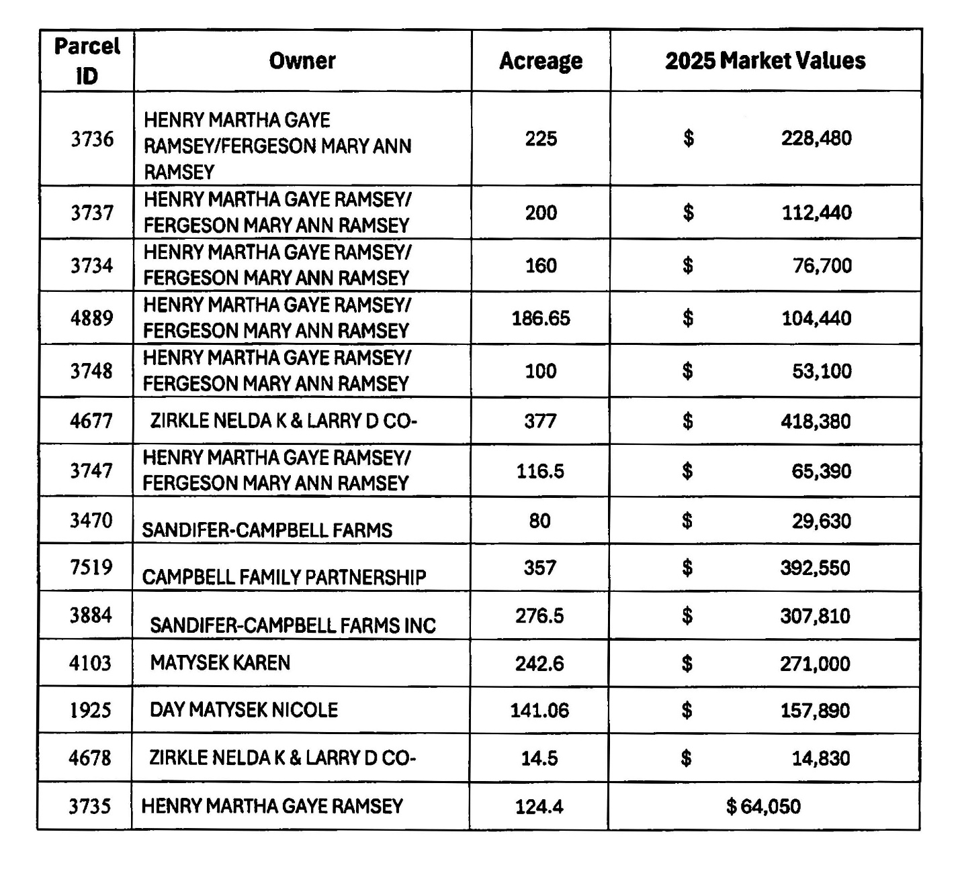

Exhibit A (Continued)
Maps of
Pease River Solar Reinvestment Zone

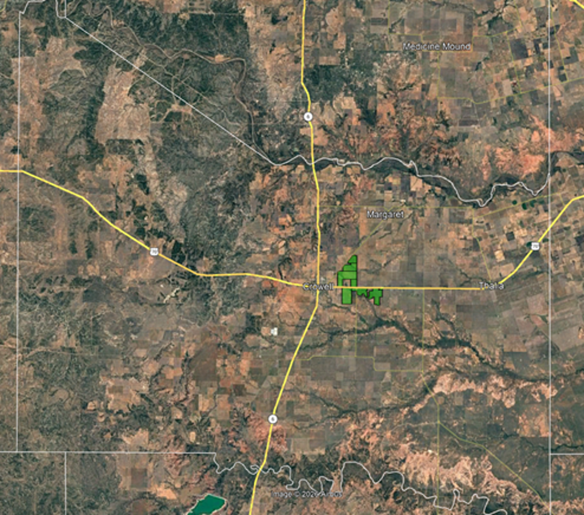

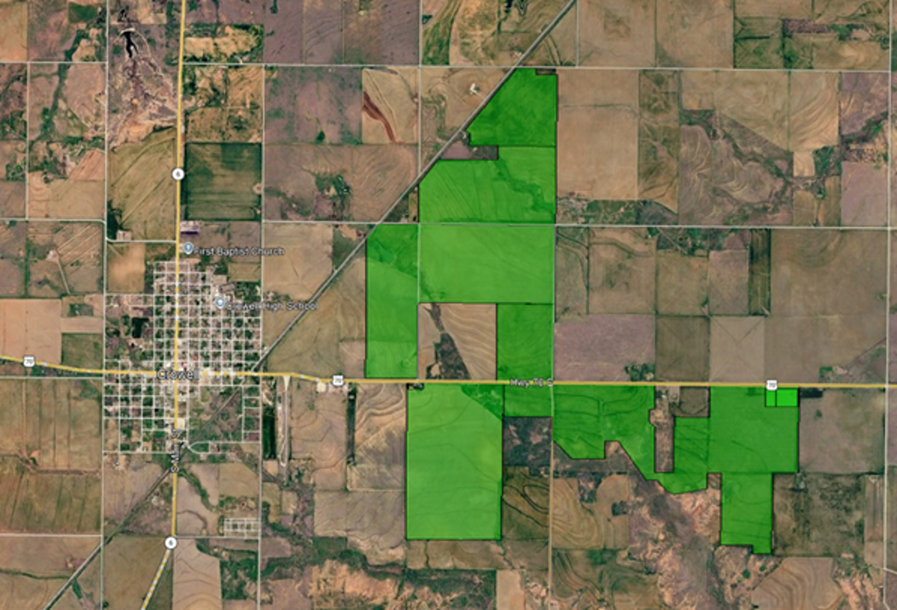

Attachment B

LOCAL SPENDING AND SUPPORT PLAN

- In connection with the construction and operation of the Improvements in the County, Owner and Owner’s prime contractor(s) (“Prime Contractor(s)”) responsible for overseeing construction and/or operation of the Improvements will use commercially reasonable efforts during the Term to purchase at least two hundred fifty thousand dollars ($250,000.00) in services, materials and supplies from County individuals and businesses, provided that nothing in this paragraph shall require Owner or the Prime Contractor(s) to use services, materials and supplies provided by County residents that are not: (i) of similar quality to those provided by nonresidents; or (ii) made available on terms and/or at prices comparable to those offered by nonresidents. Within ninety (90) days following the COD, Owner shall provide the County with a written report showing the status of spending in the County and its compliance with the requirement set forth in this Local Spending and Support Plan.

- In no event shall Owner or the Prime Contractor discriminate against County residents or businesses in employment or in the purchase of goods and services.

- In filling employment vacancies in connection with the Project, Owner and the Prime Contractor(s) will use commercially reasonable efforts to use County labor, provided that nothing in this paragraph shall require Owner or the Prime Contractor to employ County residents who are not: (i) equally or more qualified than nonresident applicants; or (ii) available for employment on terms and/or at salaries comparable to those required by nonresident applicants. Individuals who resided in Foard County at the time of their initial employment shall be considered “County labor” even if they relocate to a residence outside of the County during their term of employment.

- Owner or the Prime Contractor shall designate a Coordinator of Local Hiring and Services during the construction of the Project who will act as a liaison between all contractors and any individual or business residing in the County who is interested in obtaining information about (i) employment, or (ii) commercial services or supplies expected to be purchased by a contractor.

- Owner or the Prime Contractor shall hold a job and contracting information session prior to beginning physical construction of the Project at which information will be provided regarding the construction and hiring needs of the Project. Such information also will be provided on a continuing basis through the Coordinator of Local Hiring and Services.

- During the Term of this Agreement, Owner shall use commercially reasonable efforts, and where applicable by law, to invoice purchases locally to ensure that sales/use taxes are credited to the benefit of the County.

Attachment C

Owner’s Annual Reporting and Compliance Form
Pursuant to Section VI(B) of the Agreement, this form shall be submitted by Owner to the County Judge on or before April 30th of each Calendar Year beginning with the first Calendar Year after Owner delivers the Certificate. To the extent that any of the provisions herein conflict with the provisions in the Agreement, the provisions of the Agreement shall control.
Provision and Description | Compliance Guidelines | Provision Complied With?
 |  | Yes (date complied with)/No/In Process (include explanation)
Improvements and Reinvestment Zone – Section III(A) | Owner constructed the Improvements on the Site as set forth in Section III(A).
Improvements and Reinvestment Zone - Section III(C) | Owner commenced construction of the Improvements and the Project achieved Commercial Operations as required by the timelines.
Representations - Section V | Owner has made all required filings with the Office of the Comptroller of Public Accountants and other governmental entities concerning the Agreement.  Note: Any filings made during the course of the prior year by Owner which pertain to the Agreement should be listed here.
Assignment - Section IX | Describe any instances in which the Agreement was duly assigned or transferred in accordance with Section IX of the Agreement.
Local Spending Plan – Attachment B, Section A | During construction of the Project and within 90 days following the COD, Owner provided the County with a written project summary showing its good faith and commercially reasonable efforts to comply with the requirements set forth in the Local Spending and Support Plan (in the form of Attachment B), which includes all reasonably available local spending information collected by Owner in the ordinary course of business including (among other information):  - Summary of Local services/materials/supplies purchased within the County  - Proof that Owner designated a Coordinator of Local Hiring Services (per Attachment B, Section D)  - Proof that Owner used commercially reasonable efforts to utilize the County Labor Force by conducting a job and contracting information session within 30 days of beginning physical construction of the Project (per Attachment B, Section E)
Local Spending Plan – Attachment B, Section D | Owner or the Prime Contractor designated a Coordinator of Local Hiring Services who acted as a liaison to residents of the County.
Full-time Project Jobs – Section V(C) | For every year during the Abatement period, Owner, its contractors, their respective affiliates, or service providers engaged to provide goods or services in connection with the operation of the Improvements have collectively employed at least the requisite number of full-time Project employees as described in Section V(C).

